**Template for Evidence(s)**

**UI GreenMetric Questionnaire**

University : Universitas Trisakti

Country : Indonesia

Web Address : <https://trisakti.ac.id/>

**Prodi**

**Teknik Perminyakan**

**[6] Education and Research (ED)**

**[6.5] Total Research Funds (in US Dollars)**

|  |
| --- |
|  |
| [Rekap Penelitian - Google Drive](https://drive.google.com/drive/folders/1jXvaK5eOMVPaaCPFVhfwDUrDAGS0WSTN) |

**Description:**

Total dana penelitian di 2021 = $ 25,110

Total dana penelitian di 2022 = $ 25,751

Total dana penelitian di 2023 = $ 36,078

Total dana penelitian selama 3 tahun (2021 – 2023) = $ 86,939

**Template for Evidence(s)**

**UI GreenMetric Questionnaire**

University : Universitas Trisakti

Country : Indonesia

Web Address : https://trisakti.ac.id

**Prodi Teknik Geologi**

**[6] Education and Research (ED)**

**[6.5] Total Research Funds (in US Dollars)**

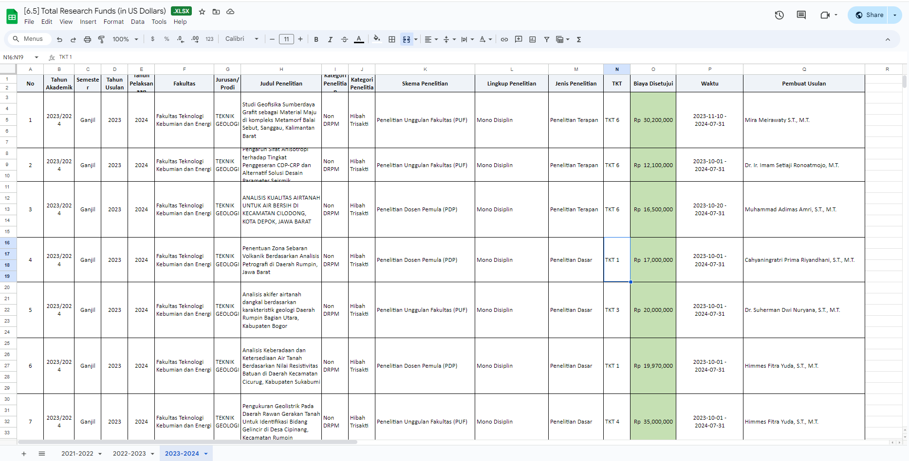

Link Data Penelitian terkait sustainbility : [Daftar Penelitian Sustainibility](https://docs.google.com/spreadsheets/d/15CLt8sDpc3LBBhjJuMokChuPWtnWAaq3/edit?usp=drive_link&ouid=104184878661358209576&rtpof=true&sd=true)

**Description:**

Total Penelitian yang terkait sustainability pada tahun 2021-2022 = $ 1.024,43 US Dollars

Total Penelitian yang terkait sustainability pada tahun 2022-2023 =  **$** 1.776,83 US Dollars

Total Penelitian yang terkait sustainability pada tahun 2023-2024 = $ 1.613,86 US Dollars

Total Penelitian yang terkait sustainability selama 3 tahun terakhir = $ 4.415,12 US Dollars

**Template for Evidence(s)**

**UI GreenMetric Questionnaire**

University : Universitas Trisakti

Country : Jakarta Barat

Web Address : https://ftke.trisakti.ac.id

**Prodi Teknik Pertambangan**

**[6] Education and Research (ED)**

**[6.5] Total Research Funds (in US Dollars)**

|  |  |  |  |  |  |  |  |  |  |  |  |  |  |  |  |  |  |  |  |  |
| --- | --- | --- | --- | --- | --- | --- | --- | --- | --- | --- | --- | --- | --- | --- | --- | --- | --- | --- | --- | --- |
| |  |  |  |  | | --- | --- | --- | --- | | **Tabel 1. Jumlah Penelitian Terhadap Mata Kuliah Sustainibility** | | | | | Tahun Akademik | Jumlah keseluruhan mata Kuliah | Jumlah Mata Kuliah Sustainibility | Jumlah Dana Penelitian Sustainibility ( USD) | | 2021 | 95 | 15 | $1,427.87 | | 2022 | 95 | 15 | $13,183.58 | | 2023 | 95 | 15 | $12,411.95 |   Gambar 1. Diagram Penggunaan Dana Penelitian Selama 3 Tahun Terakhir |
| Link Data Penelitian terkait sustainbility : [Daftar Penelitian Sustainibility](https://docs.google.com/spreadsheets/d/1n6EizTepvf6kzu0w2JeMhwof-fIPula7/edit?usp=drive_link&ouid=104898933292286253102&rtpof=true&sd=true) |

**Description:**

Total Penelitian yang terkait sustainability pada tahun akademik 2021-2022 = 14271,87 US Dollars

Total Penelitian yang terkait sustainability pada tahun 2022 – 2023 = 13183,58 US Dollars

Total Penelitian yang terkait sustainability pada tahun 2023 – 2024 = 12411,95 US Dollars

Total Penelitian yang terkait sustainability selama 3 tahun terakhir = **39867,40 US Dollars**